LAB 1

SUBJECT: OSG202

PROFESSOR: TONG PHUOC QUAN

STUDENT NAME/ID: NGUYEN MANH BAO TIN / SE170134

CLASS: SE1710

1. IPCONFIG command on Windows:

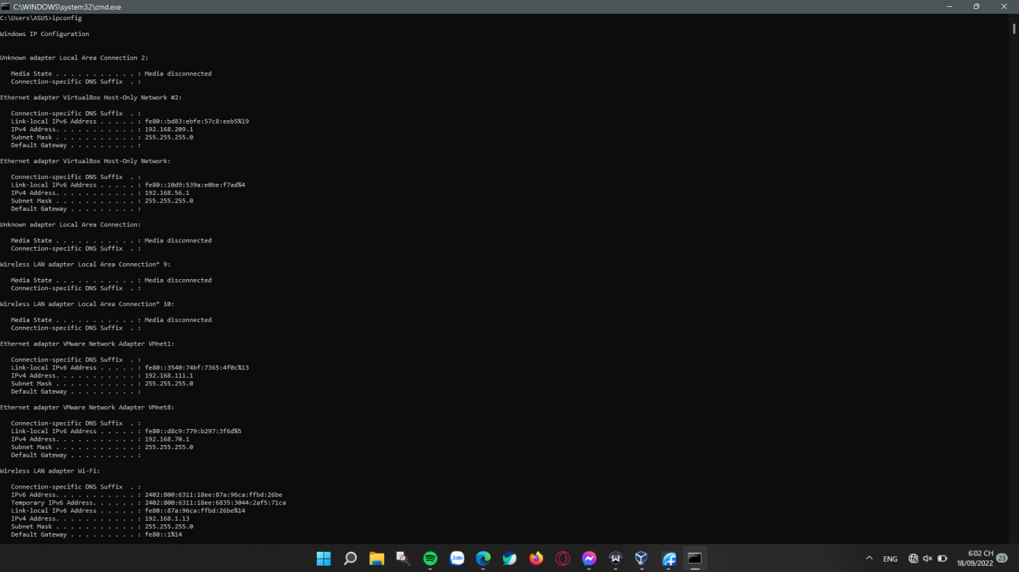

2. IFCONFIG command on Fedora 11:

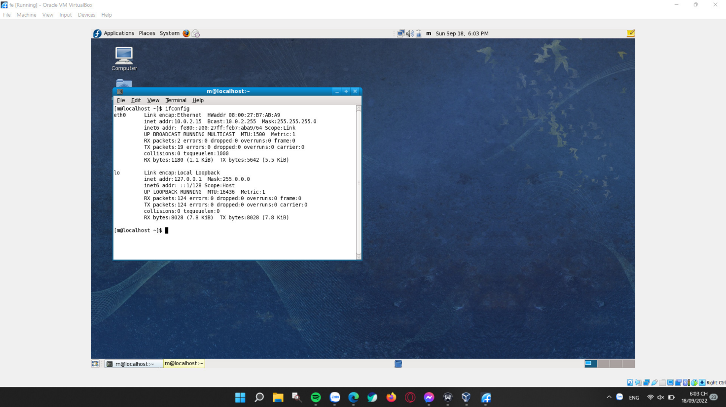

3. Sharing files between Windows 11 and Fedora:

First I configure my wanted folder to be sharable on Windows 11

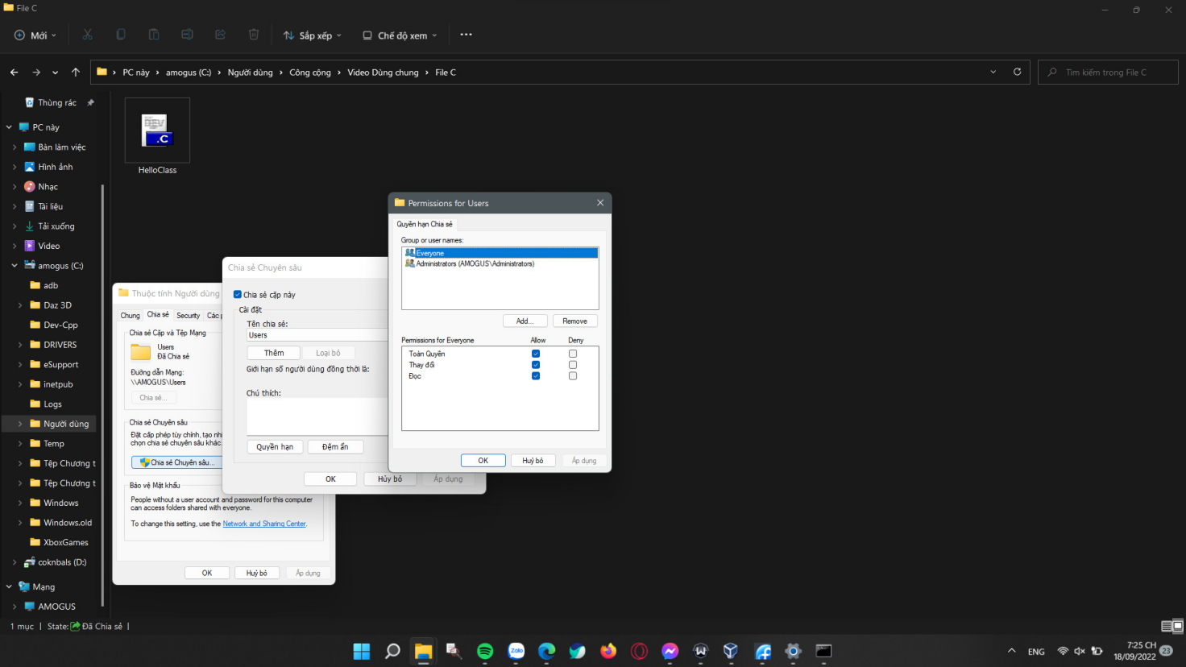

Then I use the ipconfig command within Windows Command Prompt Terminal to find out my device’s IPV4:

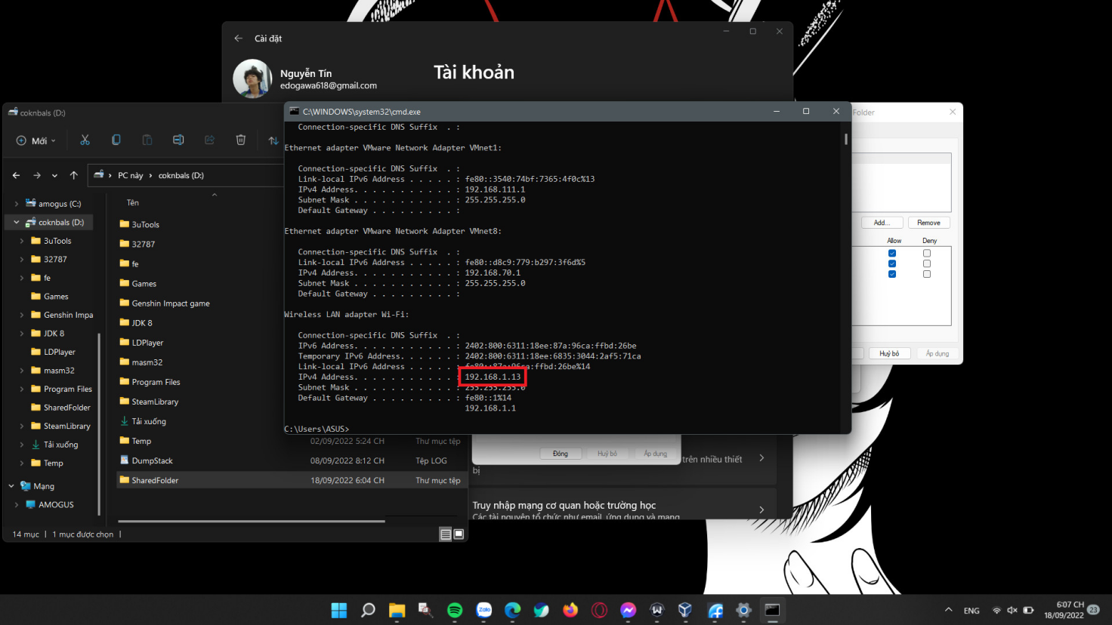

Now I switch to Fedora, using it’s Terminal interface and type in the following command:

thunar [smb://](smb:///)<Your destination IPV4>

A new window shows up and ask you to fill in some informations.

Remember Username being the name of your local user account or your Microsoft account’s email whichever being your Windows computer login username.

Domain being your Windows workgroup’s name, can be found in System Properties.

Password being your Windows computer login password.

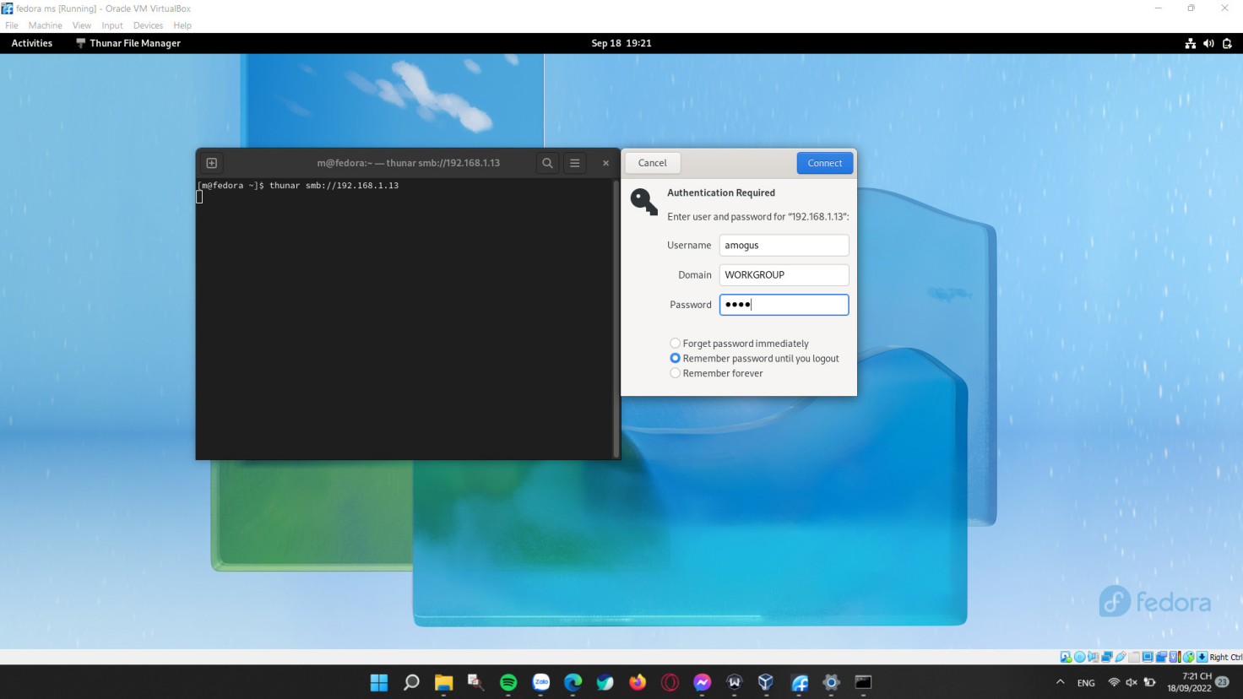After I fill in all the necessary credentials, a new window pops up and shows me the shared Windows folders.

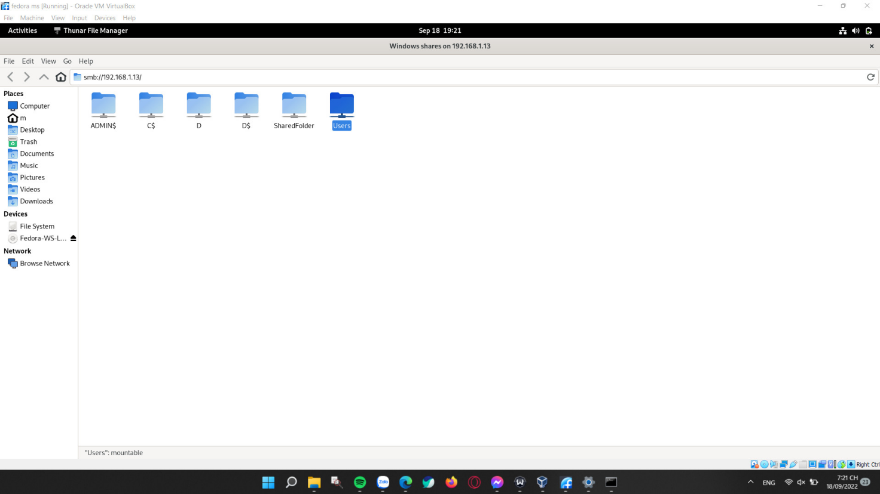

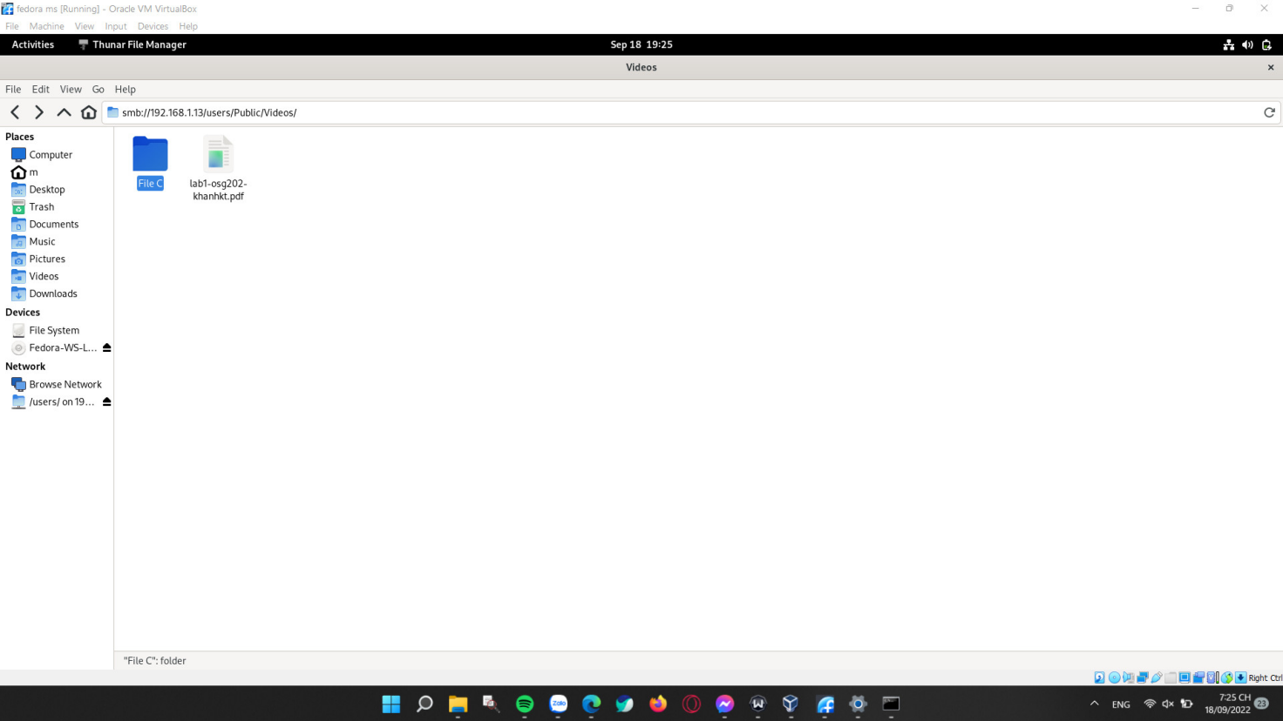

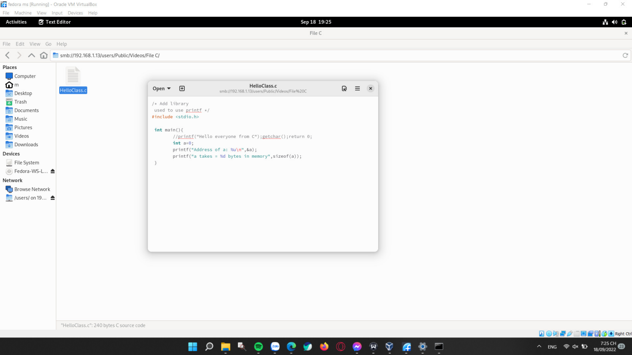

4. Midnight Commander and F6’s function explanation.

MC’s interface

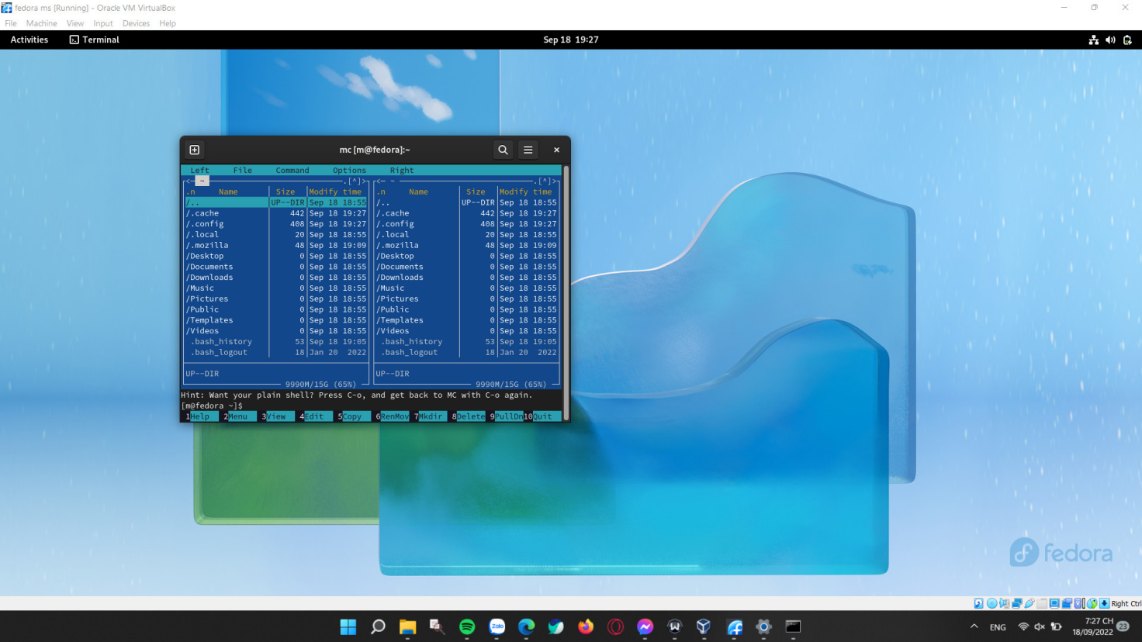

F6 Function

The F6 button helps the user to:

- Move a file or folder from a directory to another.

- Move a file or folder from a directory to another while also changing the file/folder’s name.

- Rename a file/folder.

Function demonstration:

To begin, I have a file named “HelloClass.c” at home/m/Desktop and I want to move this file to home/m/Downloads

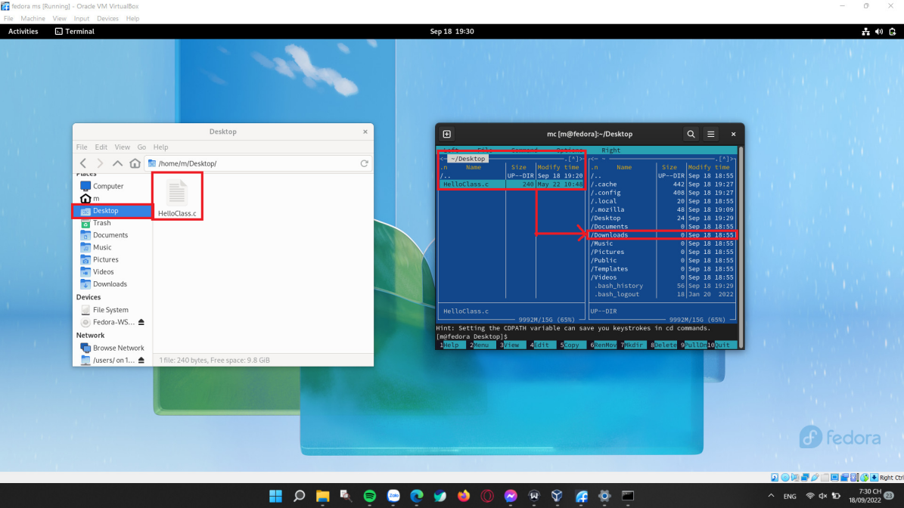

Next, I choose that file on the Midnight Commander (clicking mouse or using arrow keys). Then, I press the F6 key on the keyboard, and a box will appear as below.

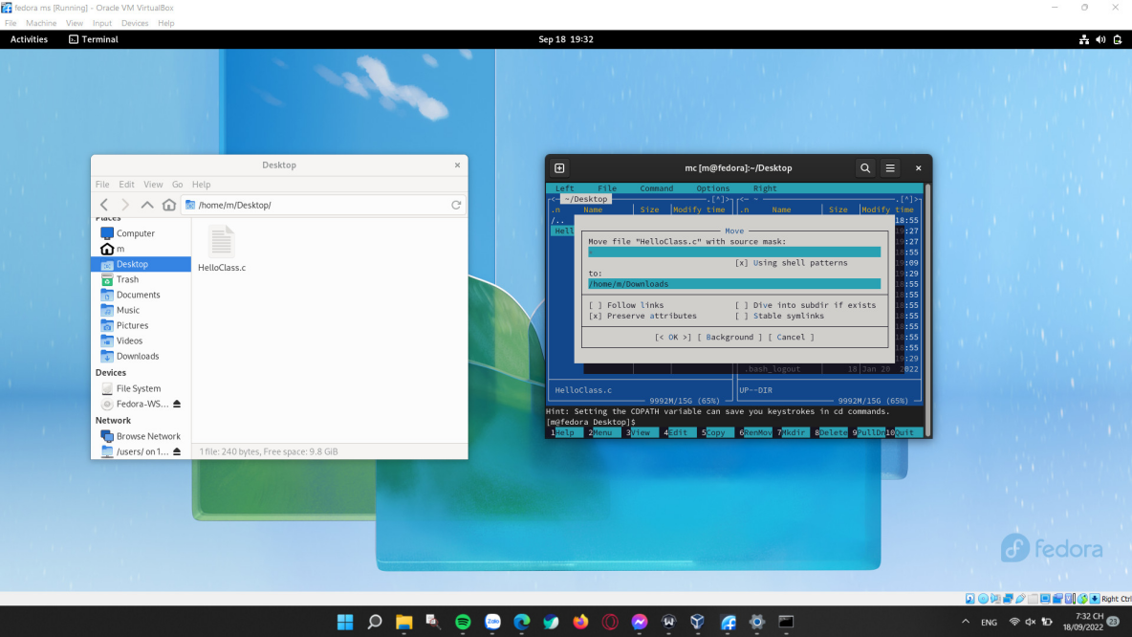

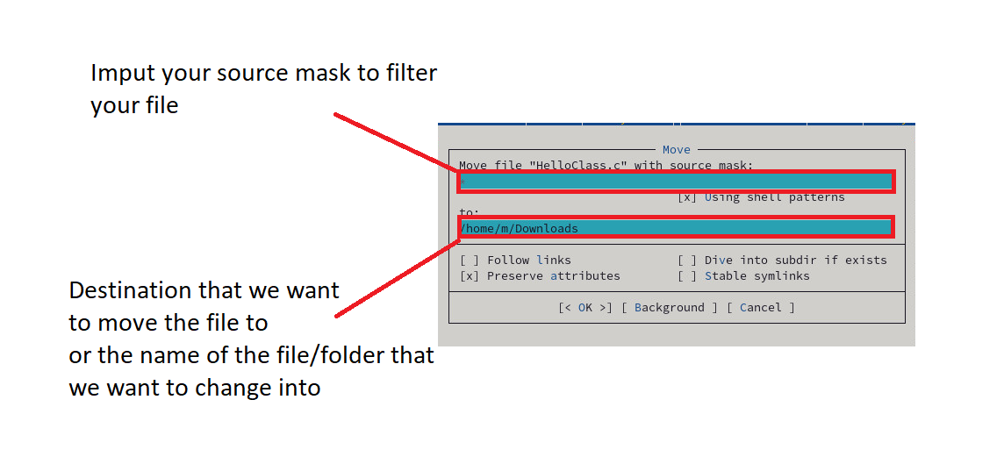

After setting everything, I press Enter. As a result, my file “HelloClass.c” has been moved to the destination.

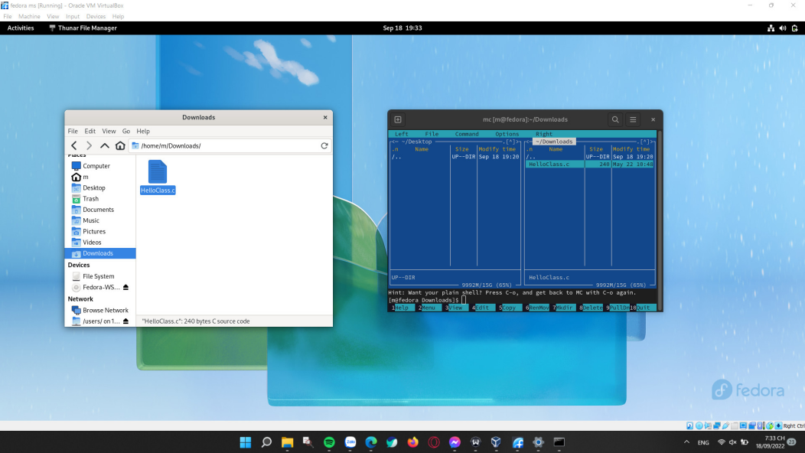

Now I want to change my file name from “HelloClass.c” to “XinChao.c”. I choose my file in Midnight Commander and press F6. Then I fill in the box as below:

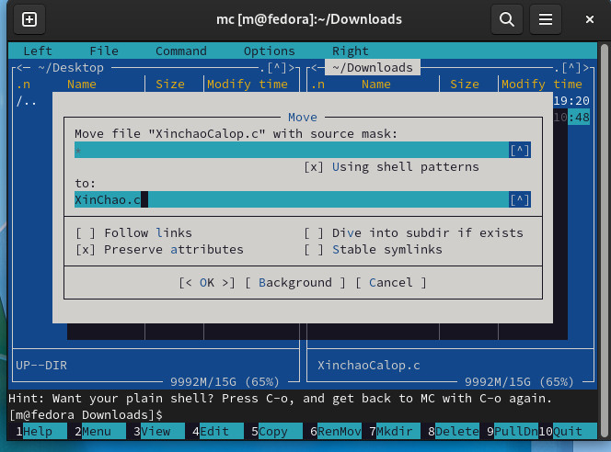

Then press Enter, and I have my result, the file name has been changed from “HelloClass.c” to “Xin Chao.c”

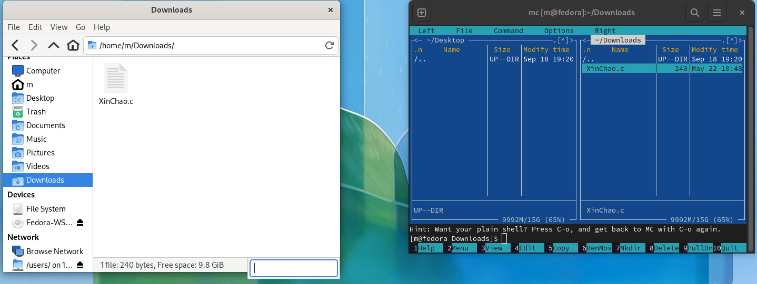

5. Compile C program with Fedora’s Terminal

The program I wrote will print out on the screen with the text “Hello everyone from C”

